**Lab#1(a) Adding a external stylesheet to make registration form look elegant.**

|  |  |  |
| --- | --- | --- |
| **TAGS USED** | **ATTRIBUTES USED** | **DESCRIPTION** |
| <HTML> | -- | Write the description of HTML tags and attributes |
| <HEAD> | -- | Write the title and meta tags here |
| <META> | CHARSET,NAME | its attributes for metadata. |
| <TITTLE> | -- | Write the title your website |
| <STYLE> | -- |  |
| <BODY> | -- |  |
| <FORM> | ACTION,METHOD | attributes for user input and data submission. |
| <LABEL> | FOR | attribute of the  corresponding input element |
| <INPUT> | TYPE,TEXT,EMAIL,TEL,  PASSWORD,RESET,SUBMIT |  |

**Final Outcome:**

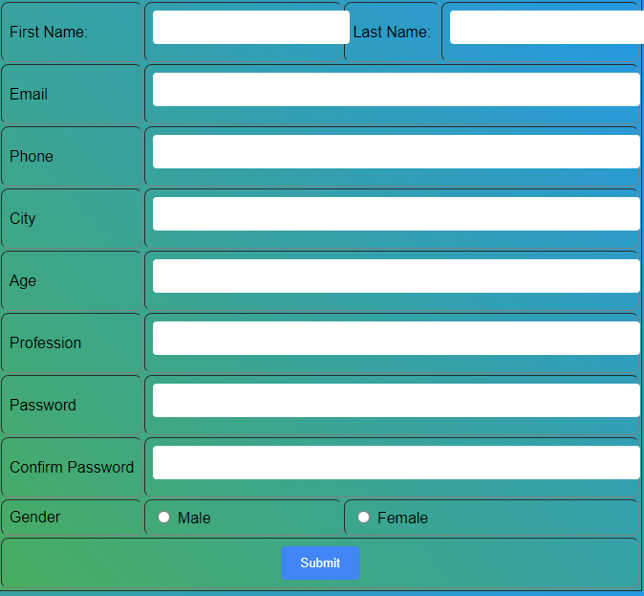

**Code Snippet:**

body, h1, h2, p {

margin: 0;

padding: 0;

}

body {

background: linear-gradient(45deg, #4CAF50, #2196F3);

font-family: Arial, sans-serif;

}

table {

margin: 0 auto;

}

td {

padding: 8px;

border-radius: 8px;

}

input[type="text"],

input[type="email"],

input[type="tel"],

input[type="password"] {

width: 98%;

padding: 10px;

border: none;

border-radius: 4px;

margin-bottom: 10px;

}

input[type="submit"] {

background-color: #4285f4;

color: white;

border: none;

border-radius: 4px;

padding: 10px 20px;

cursor: pointer;

}

input[type="submit"]:hover {

background-color: #3578e5;

}